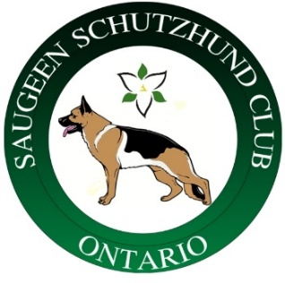 Saugeen Schutzhund Club Fall Club Trial

Trial Date: September 11 – 12, 2021
Judge: Frank McEniry GSSCC
Helpers: James Siler & John Bonello
Location: Saugeen Club Field 374127 6th Line of Amaranth, Orangeville, ON L9W 0M6
Tracking: Either sod or mixed grass (to be confirmed closer to trial depending on conditions)
Practice Times: Wednesday September 1, 2021 field obedience
Sunday September 5, 2021 (tentative date depending on helper availability)
Entries Close: September 4, 2021 or when trial is full (which ever happens first)
Judge’s Dinner: Depending on Covid restrictions there will be a barbecue on Saturday September 11, 2021 (details will follow closer to date)
Notes:
- Ontario Covid 19 for safe trials and provincial restrictions current at the time of the trial will be adhered to.
- Handler (Canadian Residents) must be a current member of the GSSCC. Handlers that are not Canadian residents must be members in good standing of the GSSCC or a WUSV affiliate club.
- No refunds will be issued.
Fees: Payment to be made to Saugeen Schutzhund Club by e-transfer mary@olympusk9.com
BH-VT $75.00
AD $75.00
IGP 1-2-3 $100.00
OB (UPr) 1-2-3 $75.00 (Obedience only)
TR (FPr) 1-2-3 $75.00 (Tracking only)
Entry only accepted using https://gsscc360.ca
Entry form and payment in full must be submitted for acceptance in the trial to be confirmed.
Questions:
Trial Manager: Katty Santerre - for entry questions contact ksanterre21@gmail.com
Club Contact & Secretary: Julia Stemp 2jstemp@gmail.com

